**Example Application III (Modelling Citation Analysis)**

The paper “Population dynamics of fox rabies in Europe” by Anderson et al. (Nature: 1981: 289: 765-771) developed a mathematical model for the dynamics of the interaction between fox populations and rabies. The authors note *iter alia* that there is a 3 to 5 year cycle in fox populations infected with rabies. A plot of the citations per year for this paper (see below) is suggestive of a 3 to 5 year cycle in citations (with an increasing trend)[1].

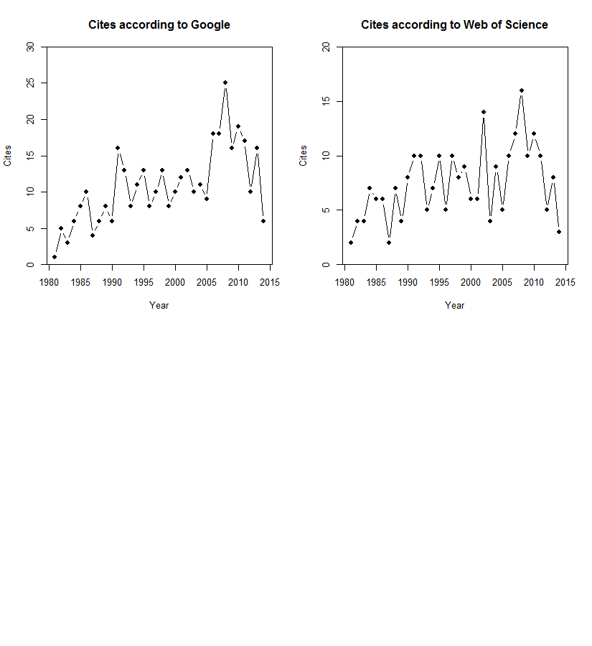

The objective of this assignment is to use TMB to fit a model in which citations according to Google exhibit a trend (linear or exponential) with a cyclic component (modelled as sine wave). You can assume that citations are Poisson-distributed. Compare your best-fit model with a model in which the cycle has a 4-year-period, using AICc. Also, plot the fits.

The pattern is more apparent if citations are extracted from Google – see how well your model performs when the cites are based of Web of Science.

What did you learn about using TMB in this case?

1. This is pretty scary, lets be honest! Mind you it is not first time seemingly unrelated things are coincident: http://www.school-for-champions.com/history/lincolnjfk.htm#.U5kVrPldXAs